**Koyo’s Newest Grinding Machine Models: VGF300 and C1003**

**VGF300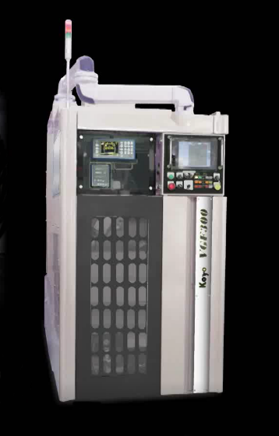 C1003**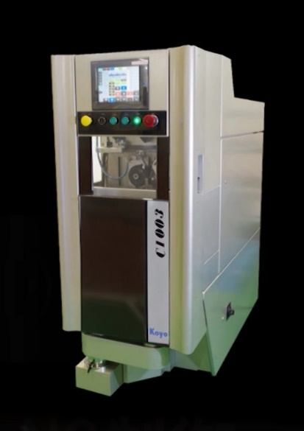

Koyo's newest grinding machine, the VGF300 Vertical Spindle Type Grinder, is all about doing more with less. This grinder offers more applications than ever before in one grinder, plus double the rigidity of older designs for improved machine performance. The VGF does all this with less equipment, less time and less use of floor space.

Although the “V” in VGF indicates vertical, it could just as easily stand for “versatile”. This machine uses a common platform that can perform various grinding applications. By adding optional grinding wheel spindles, the VGF can perform surface, O.D. or I.D. grinding applications. When O.D. and End-face grinding, the maximum grinding capacity is Ø350mm x L180mm (Ø13.5” x L7”).

At only 1,100m (approximately 43”) wide, the VGF300 offers a sleek space-space saving design. Multiple VGF300 Grinding Machines can be neatly stacked side by side without the use of intermediate conveyors. Other machine benefits are the easy side maintenance access and the option of adding a robot loading system, which makes a short turnkey grinding line possible.

Koyo has also recently introduced the C1003 Centerless Grinding Machine, which is ideal for small centerless infeed-type workpieces (Max. Ø5mm x L30mm). Although the “C” in C1003 indicates centerless, it could just as easily stand for “compact”. The C1003 contains the base machine, control box and coolant tank as an all-in-one unit to create an incredibly small footprint and reduce the amount of floor space it requires. The machine’s width is only 600mm (approximately 23.5”) wide, but the advantages of this machine don’t stop there.

The C1003 also offers NC center dressing system, automatic center height adjustment, and fully automated grinding wheel and regulating wheel dressing. No experienced is necessary to operate the user-friendly C1003 and set-up error is minimized due to the combined dressing and grinding line.

Koyo is dedicated to the kaizen concept, which involves incremental improvement. Besides continuous efforts to improve the quality and efficiency of Koyo products, Koyo has been providing grinding machines and engineering expertise to customers in the automotive, heavy equipment, aerospace, medical, IT, and various other manufacturing industries for decades.

Offering over 60 different grinding machine models, Koyo is a world leader in the development and manufacture of custom centerless, surface, and specialty grinders. We can help you choose the best machine for your application. Our team of engineers and experts will assess the scope of your project and recommend the most cost-efficient, accurate and durable grinding machine for your business. [Contact us](http://www.koyomachinery.com/contact-us.html) today to request a free consultation!